Email Signature How-To
November 19, 2015
***Keep this document open while you go through the steps to add your signature. You will need to fill in your name and other information in Step 6 and then copy and paste it into Outlook!***
NOTES:
- If you use both your webmail (ie. from your phone or from home) and an email program (ie. Outlook), you will have to add signatures to both. You cannot add logos to webmail.

For Microsoft Outlook 2010
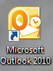
To create a signature:
- Open Outlook

- Click “New E-Mail” in the top left hand corner of the screen
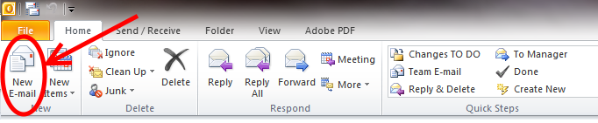
- Under the Message tab, click on “Signature” then select “Signatures” from the drop-down menu.
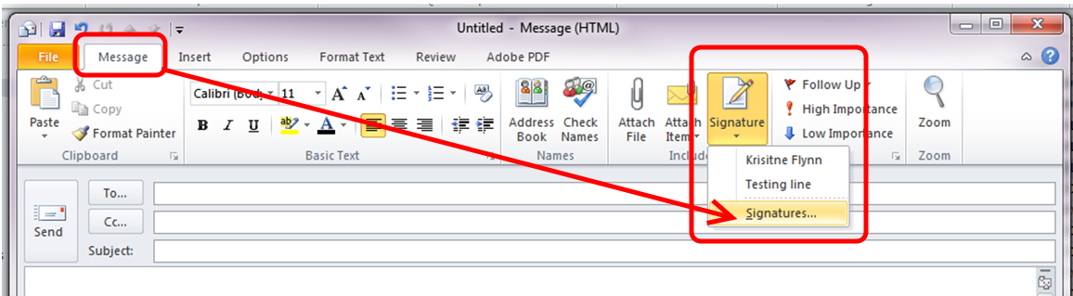
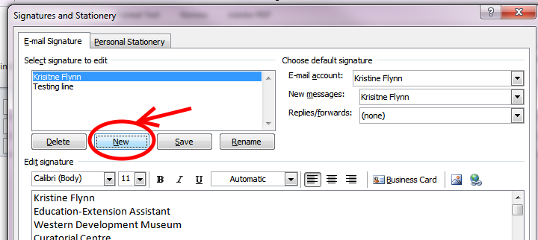
- Click on “New”

- Name your signature “External” then click OK.
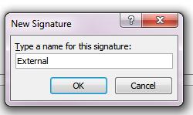

- Replace Kristine’s information with yours.
NOTES:
  - The Template uses Calibri font, size 12, text colour black.
  - Do not exceed 6 lines. Decide whether to list mobile or email for line 6.
  - Your location should be WDM Saskatoon etc. not WDM Branch or in CAPS.
Kristine Flynn
Education Assistant and Website Administrator
WDM Curatorial Centre
2935 Lorne Avenue, Saskatoon, SK S7J 0S5
P: 306-934-1400 EX. 226
M: 306-222-2222 or E: kflynn@wdm.ca

- Copy completed signature by:

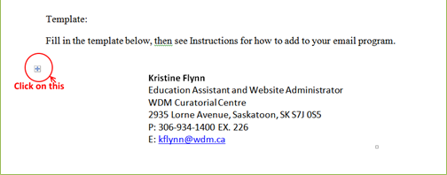

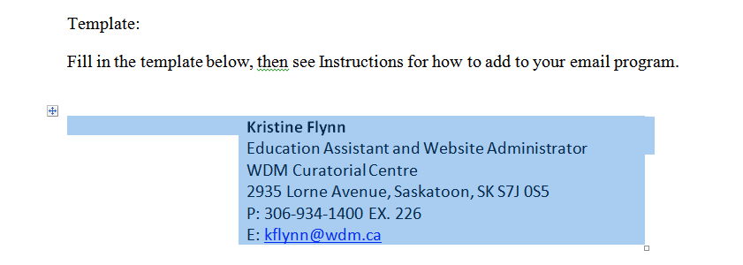
It should look like this (highlighted in blue):

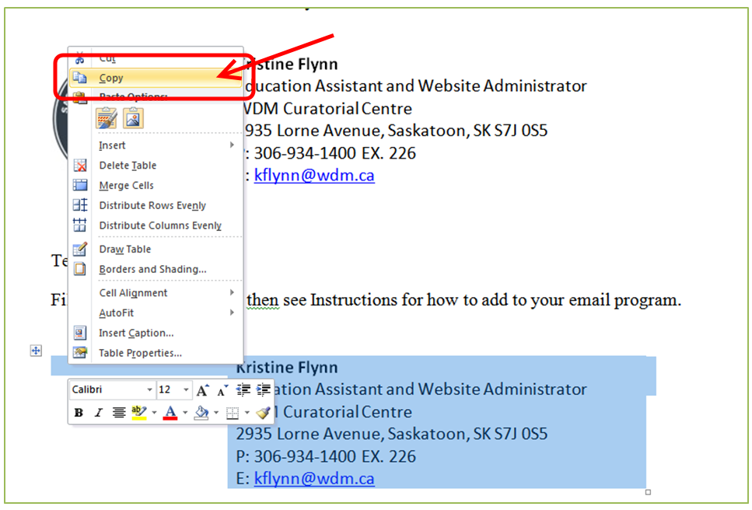
Right mouse click and select Copy

- Go back to your Outlook.
- Right click in the Signature box.
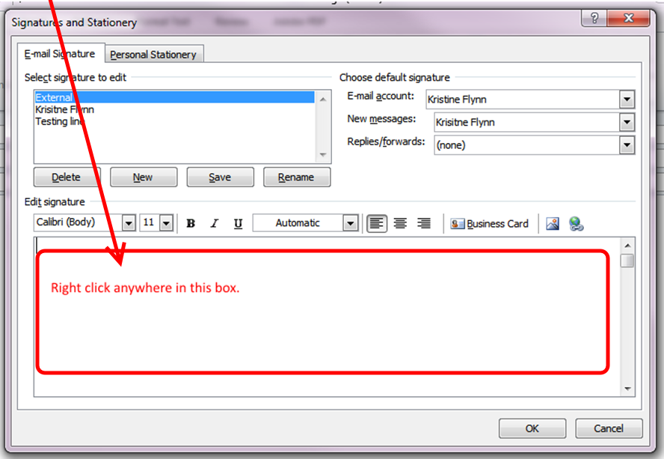

- Select Paste Option 2 (Keep Source Formatting).
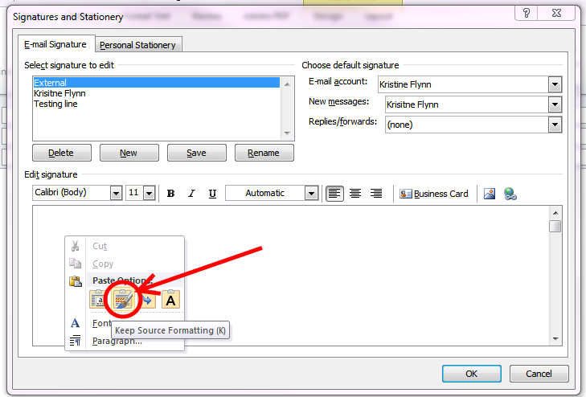
- Add logo. Left mouse click here
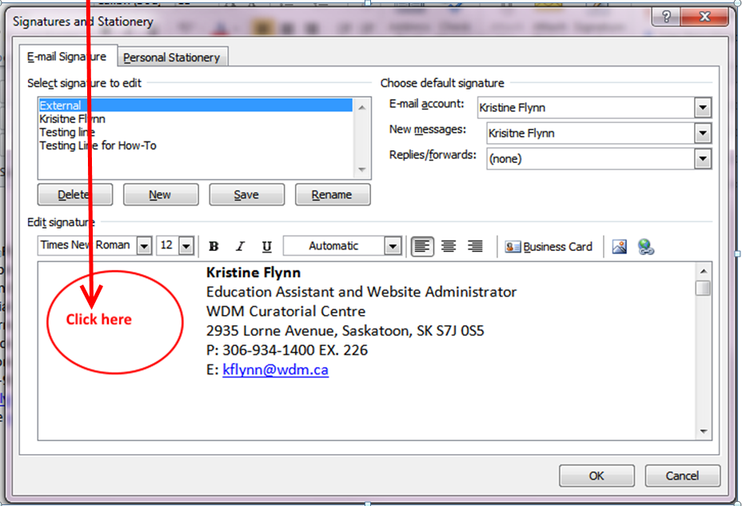

  - Click on the Add Picture icon
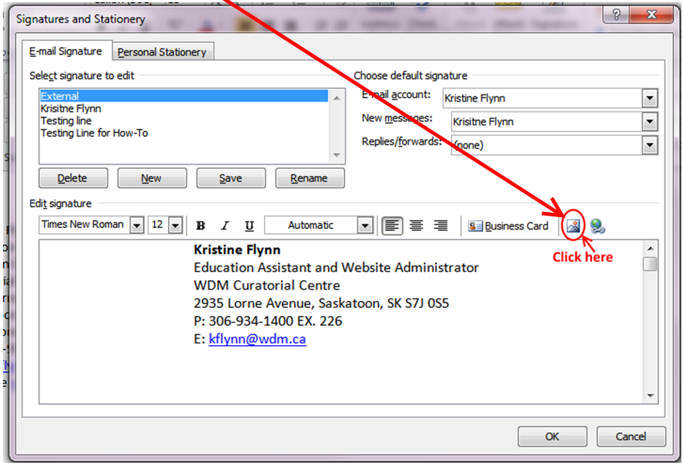
  - Enter this URL: http://wdm.ca/imagesindex/signature.jpg
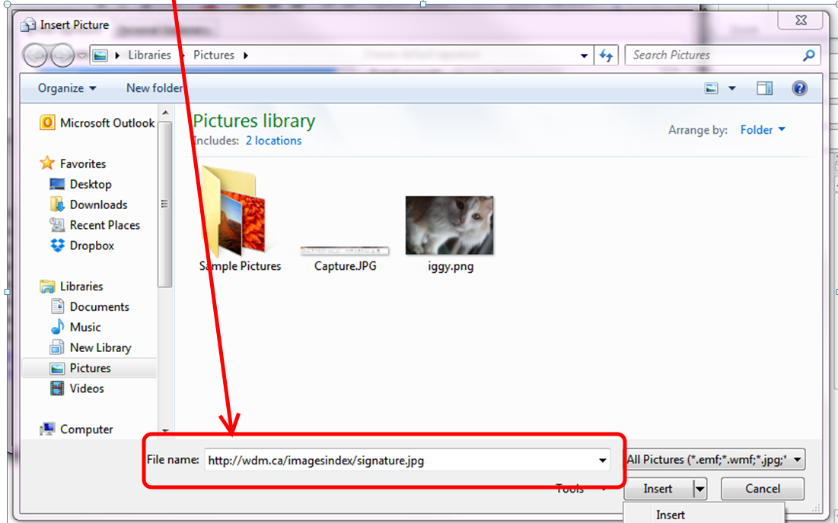

  - Click the down arrow beside Insert and select Link to File*
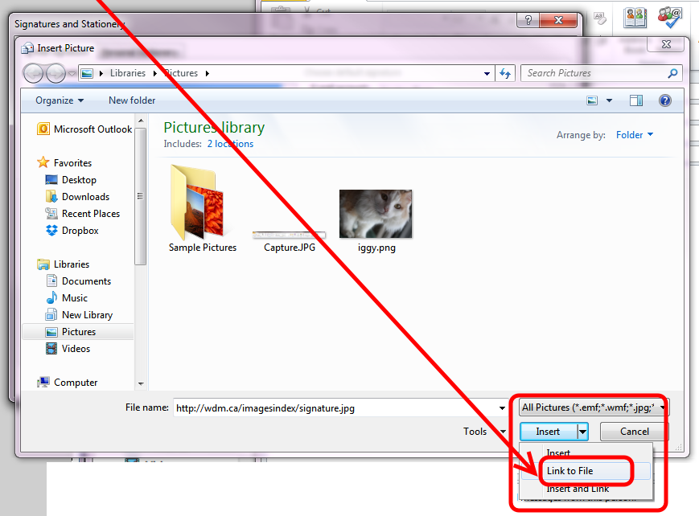
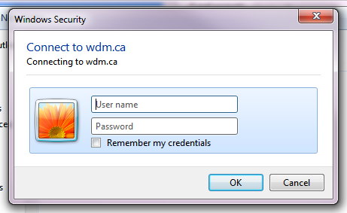
*TROUBLE SHOOTING: For some reason, this dialogue box may come up when you try to add the URL, click the Insert arrow, or select Link to File.
Click Cancel and try again. You may have to cancel and try again multiple times, but it should eventually let you do it.
YOU DO NOT HAVE TO ENTER A PASSWORD to use this logo.

- Make the logo a link to WDM website
  - Left mouse click the logo.
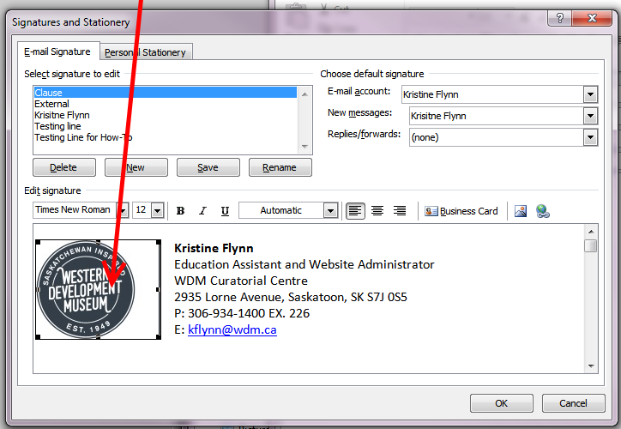

  - Click this Link button. 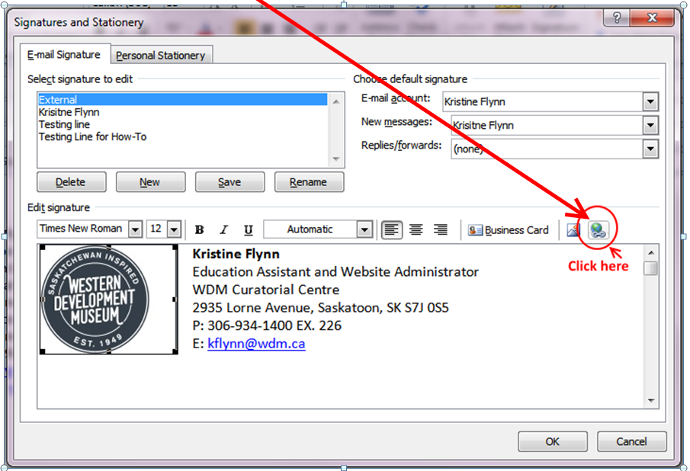

  - Enter this URL in the Address bar: http://wdm.ca/
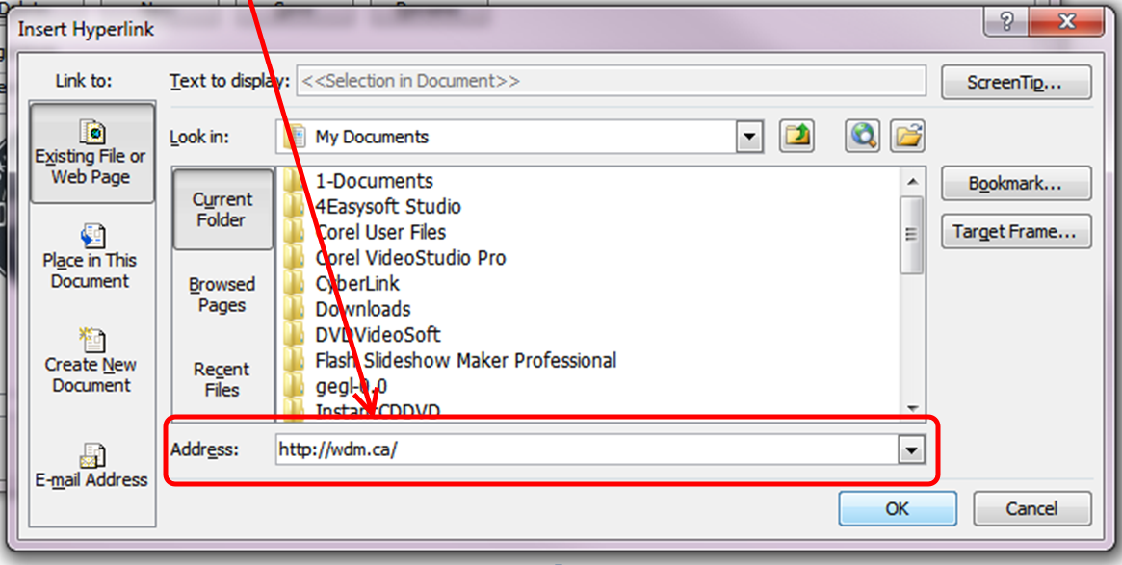
  - Click OK
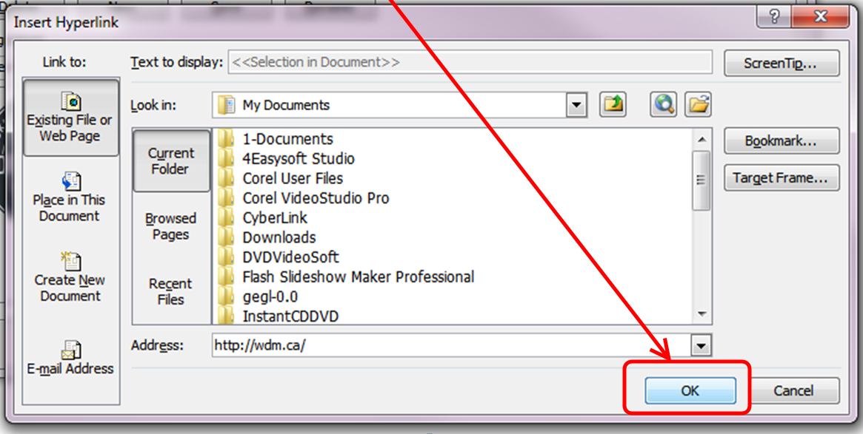

- Click OK at the bottom of the Signatures and Stationary window.
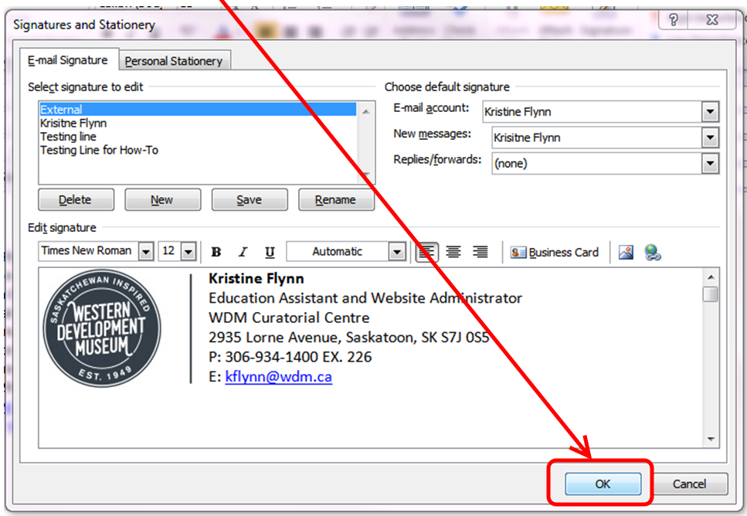

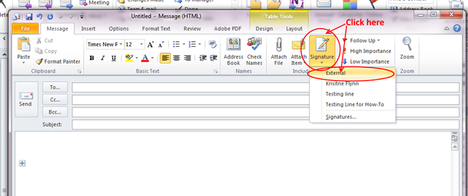
- Test your signature by clicking on the Signature button and selecting External.

It should show up in the body of your email.
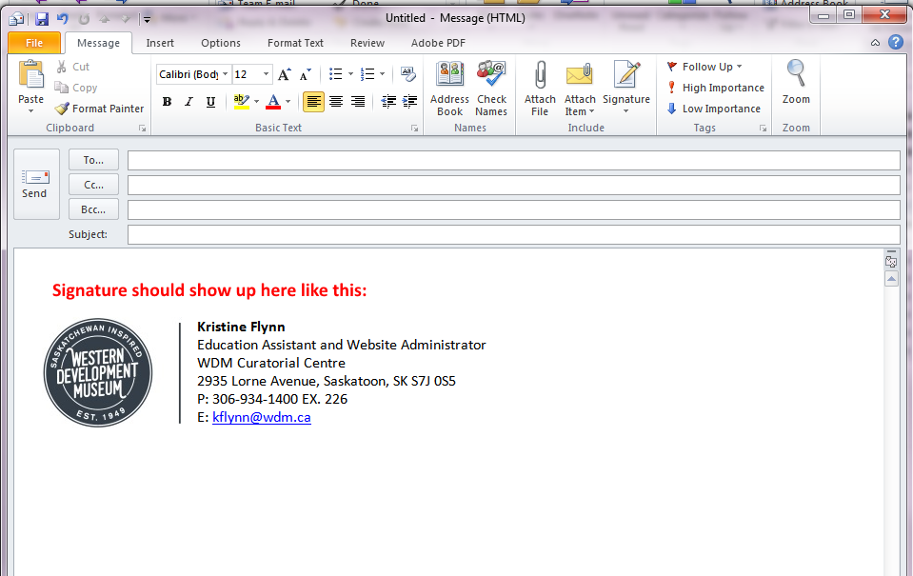

- Send a test email to the Marketing Department to make sure everything worked.
Marketing Deparment:
Tanya (tcallaway@wdm.ca)
Kerry (klubchenko@wdm.ca)
YOU ARE DONE!!!!

